Day25&26 - Task11 - AWS IAM Service

1. Create one IAM user and assign EC2 and S3 full access roles.

To create an IAM (Identity and Access Management) user in AWS and grant the user full access to Amazon EC2 and Amazon S3 services using AWS managed policies.

Step 1: Log in to the AWS Management Console
Step 2: Open the IAM Console
- In the AWS Console search bar, type IAM.
- Click IAM from the search results.
- The IAM Dashboard opens.
Step 3: Create an IAM User
- In the left navigation pane, click IAM Users.
- Click Create user.
Enter the details:

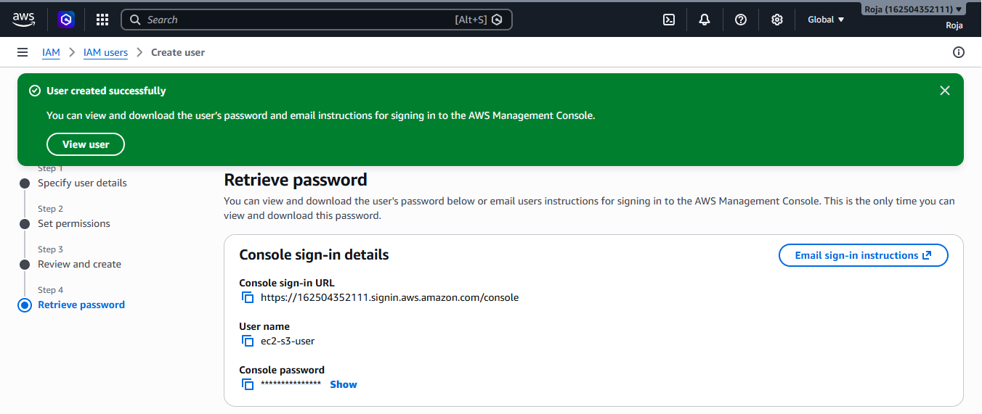
Step 4: Obtain User Sign-in Details

Console sign-in URL: IAM user login url (https://162504352111.signin.aws.amazon.com/console)
User name: ec2-s3-user
Console password: Generated or custom password (Devops@123)
Provide these credentials to the IAM user.

Step 5: Verify Attached Permissions
- Navigate to IAM → Users.
- Select ec2-s3-user.
- Open the Permissions tab.
- Confirm that the following policies are attached
AmazonEC2FullAccess Attached.
AmazonS3FullAccess Attached

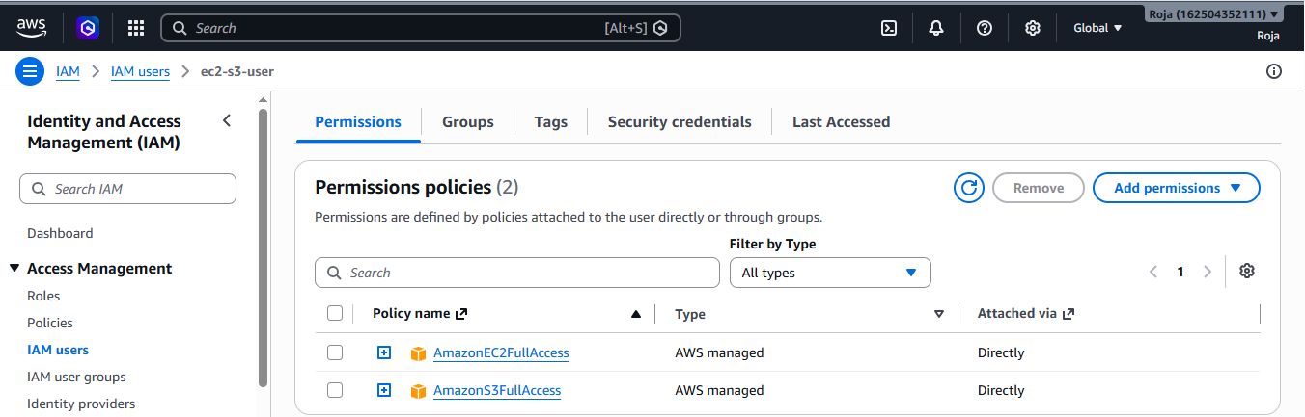

2. Create one group in IAM and assign read access for EC2.

To create an IAM group in AWS and assign read-only access to Amazon EC2 by attaching the AWS managed policy AmazonEC2ReadOnlyAccess. This allows users in the group to view EC2 resources without the ability to create, modify, or delete them.

Step 1: Open the IAM Console
- In the AWS Management Console search bar, type IAM.
- Select IAM from the search results.
- The IAM Dashboard opens.
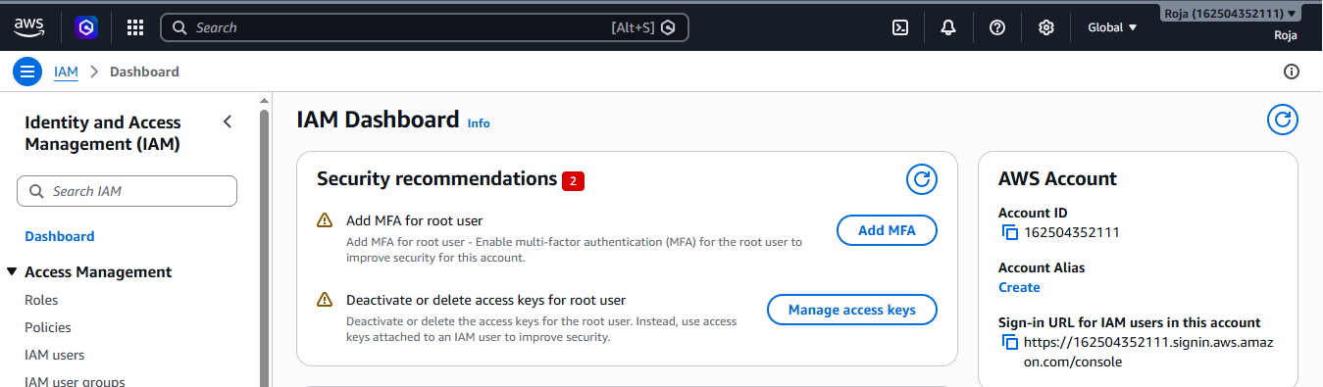

Step 2: Create an IAM Group
- In the left navigation pane, click IAM User groups.
- Click Create group. Enter the details:
Group name – EC2 ReadOnly Group
Add users to group – Select the user to be added
Attach permission policies
3. Click on create group.
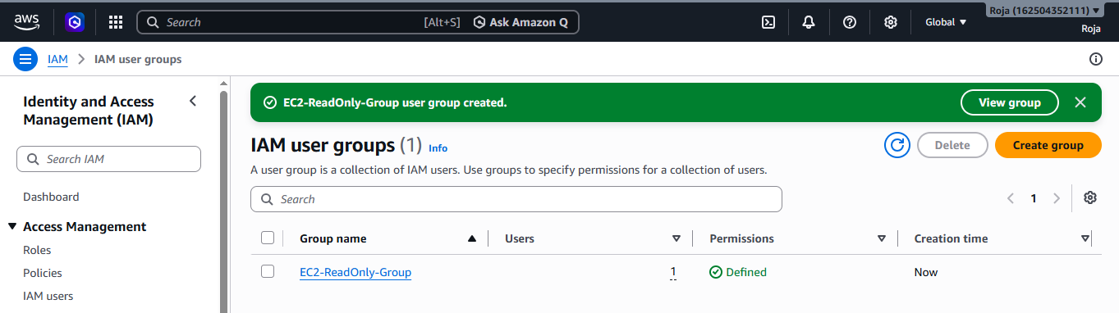

Step 3: Verified and see that user is added to the Group:
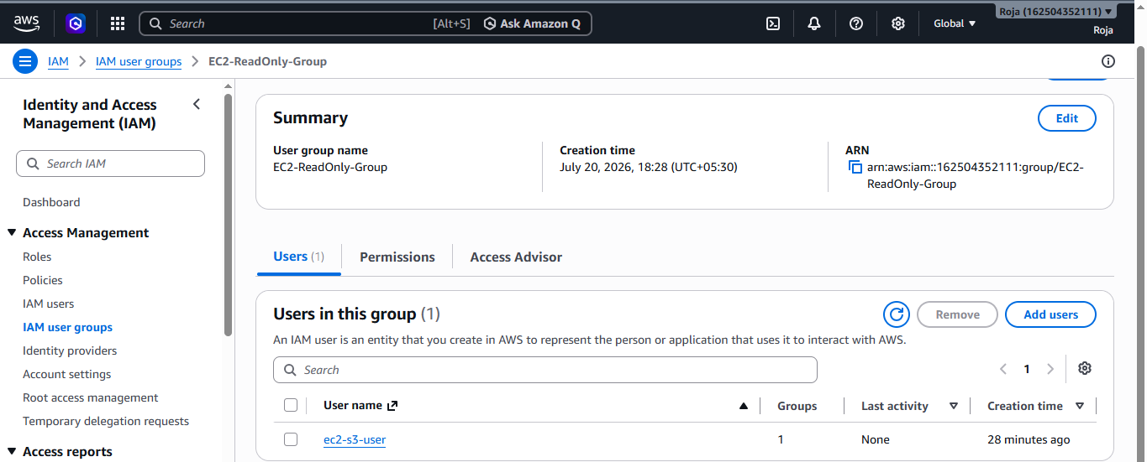

Step 4: Verify Group Permissions
- Navigate to IAM → User groups.
- Select EC2-ReadOnly-Group.
- Open the Permissions tab.
- Confirm that the following policy is attached
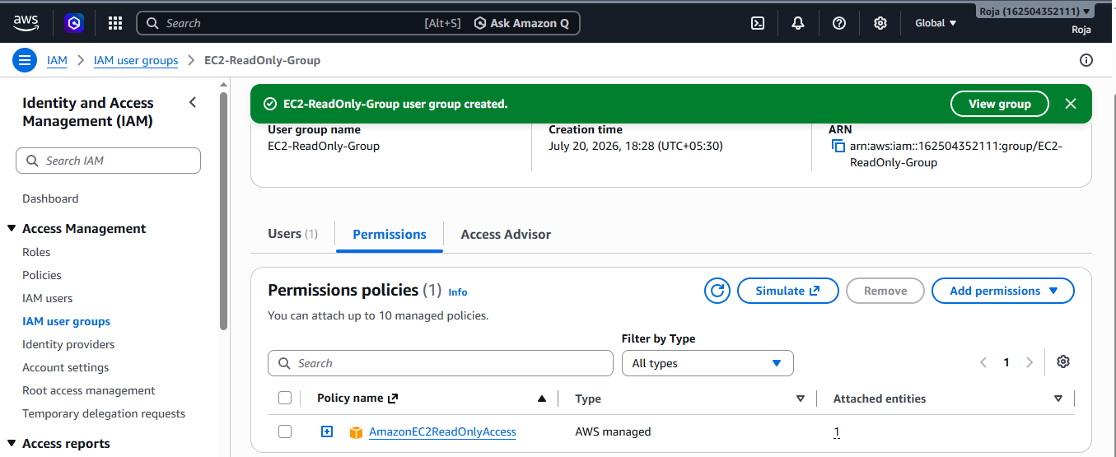

3. Create a new user named "Devops" and add to the group created in task 2.
To create a new IAM user named Devops and add the user to the IAM group created in Task 2 (for example, EC2-ReadOnly-Group) using the AWS Management Console.

Step 1: Open IAM Service
- In the AWS Console search bar, type IAM.
- Select IAM from the search results.
- In the left navigation pane, click Users.
- Click Create user.
- Create an IAM user and fill the details.
- Click on create user.

Step 2: Add User to Existing Group
- On the Set permissions page, select: Add user to group
- From the list of available groups, select the group created in Task 2.
EC2-ReadOnly-Group
3. Click Next.

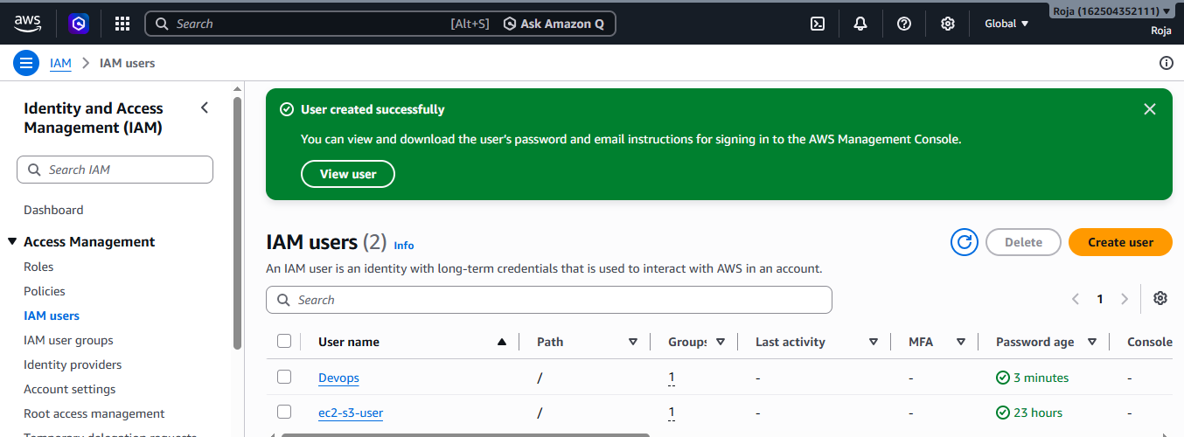

Step 3: Review and Create User
- Review the user details.
- Confirm that the selected group is correct.
- Click Create user.
A success message appears:
User Devops created successfully.

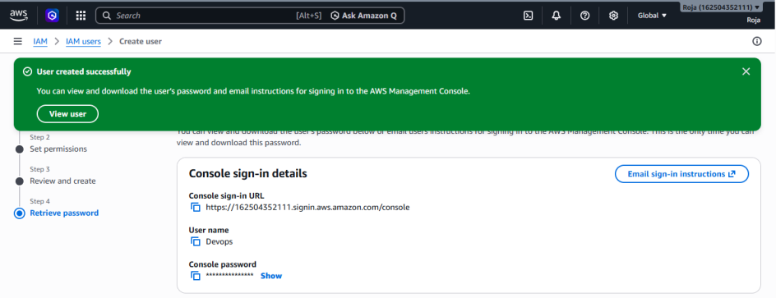

Step 4: Verify the User
- Go to IAM → Users.
- Confirm that Devops appears in the list of users.
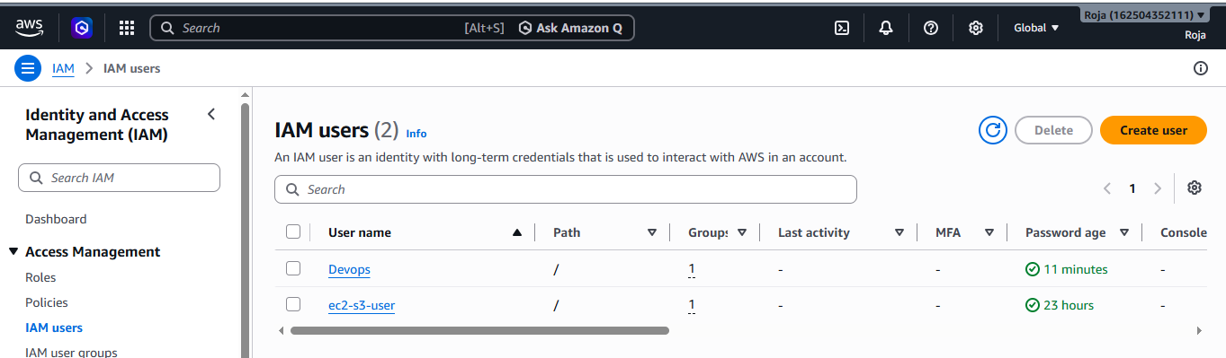
Step 5: Verify Group Membership
Method 1
- Go to IAM → Users.
- Click Devops.
- Open the Groups tab.
- Expected result:
Groups
-------
EC2-ReadOnly-Group
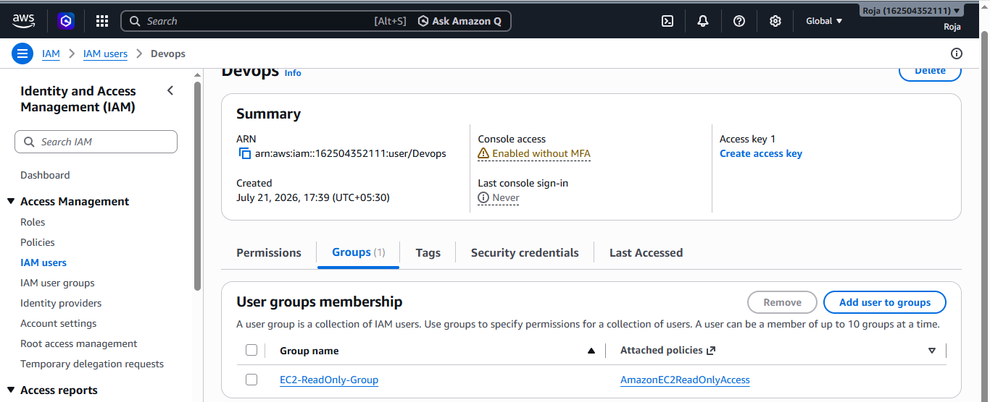

4. Write a bash script to create an IAM user with VPC full access.

To write and execute a Bash script that creates an IAM user and attaches the AmazonVPCFullAccess managed policy using the AWS CLI.

Attach the below policies to the user before execution:
Amazon VPC FullAccess
IAM FullAccess

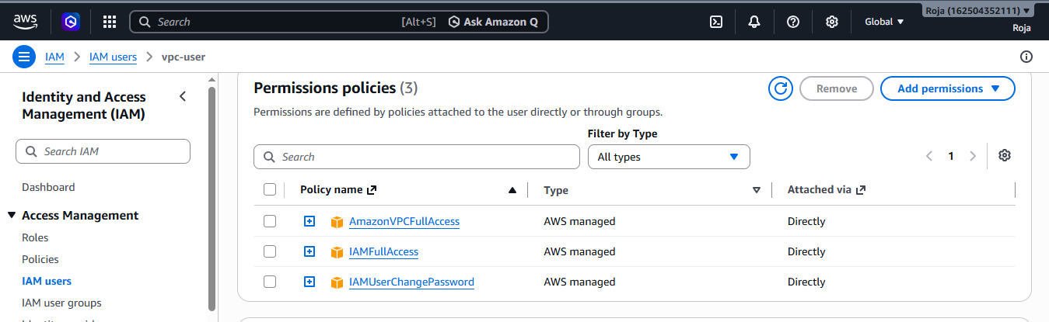

Step 1: Verify AWS CLI Installation
- aws configure
- Verify the current AWS identity:
- aws sts get-caller-identity

Step 2: Create the Bash Script
- Create a new file.
- vi create_iam _user.sh
- Press i to enter insert mode.
- Paste the script:
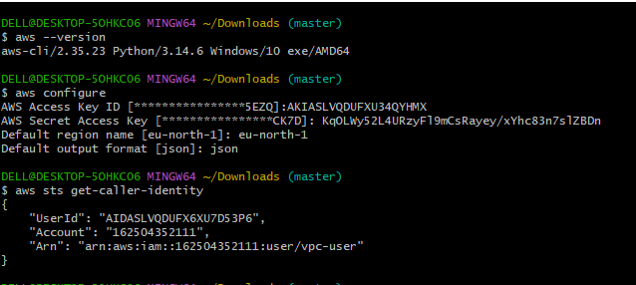

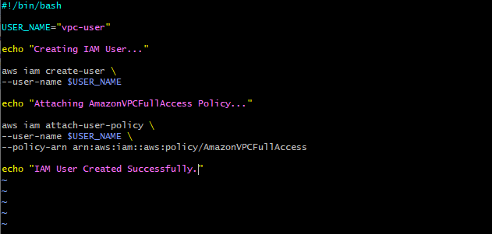

Give execute permissions and run the script:
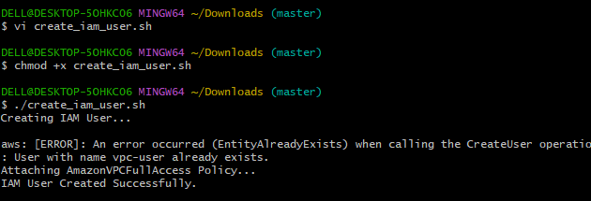

Verify IAM user and attached policy:
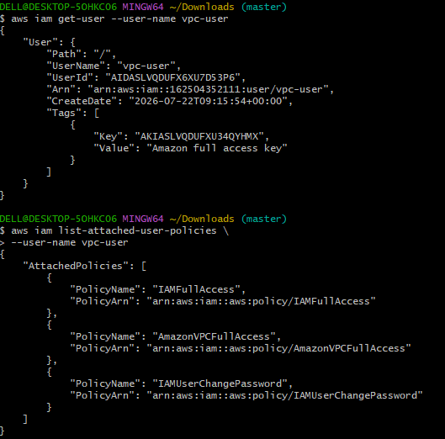

5. Create an IAM policy to allow EC2 access for a specific user in specific regions only.

To create a custom IAM policy that allows a specific IAM user to access Amazon EC2 services only in specified AWS regions.

Step 1: Open the IAM Service
- In the AWS Console search bar, type IAM.
- Select IAM from the services list.
- The IAM Dashboard opens.
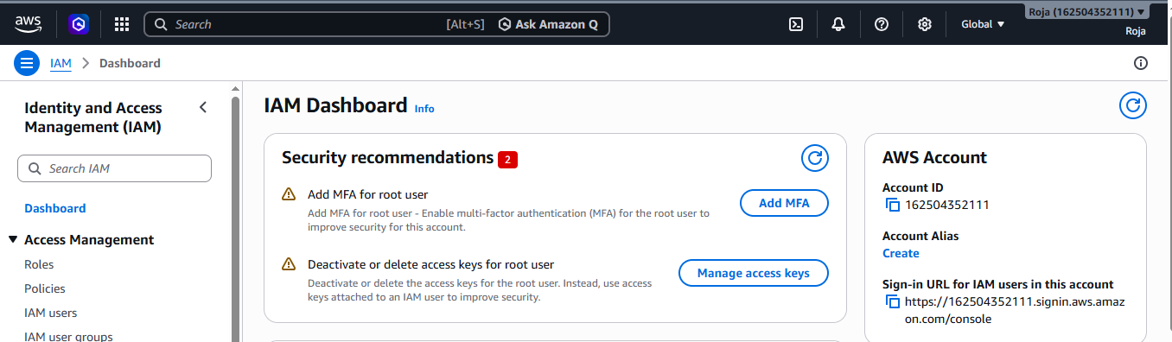

Step 2: Create a Custom IAM Policy
- In the left navigation pane, click Policies.
- Click Create policy.
- Select the JSON tab.
- Delete the default policy document.
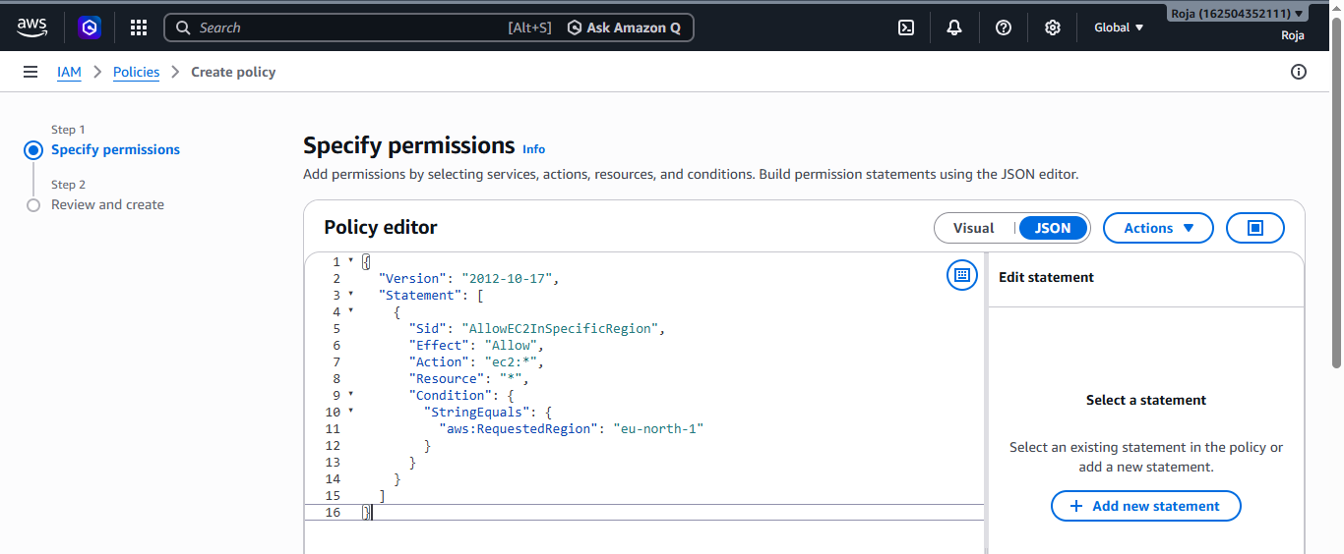

Step 3: Review the Policy
- Click Next.
- Enter the following details:
Field | Value
Policy Name | EC2SpecificRegionPolicy
Description | Allows EC2 access only in eu-north-1
- Click Create policy.
A success message will appear.
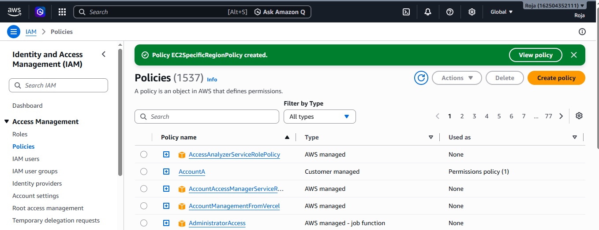
Step 4: Attach the Policy to a Specific User
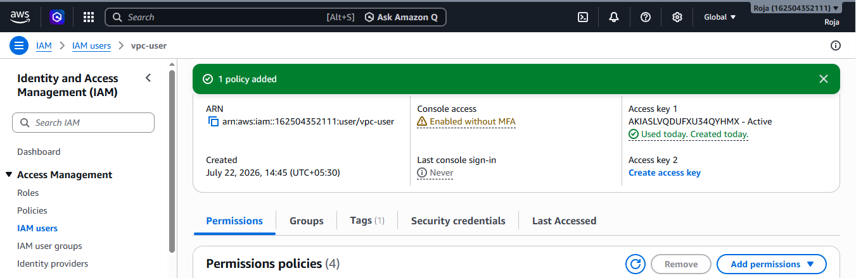

Step 5: Verify the Attached Policy
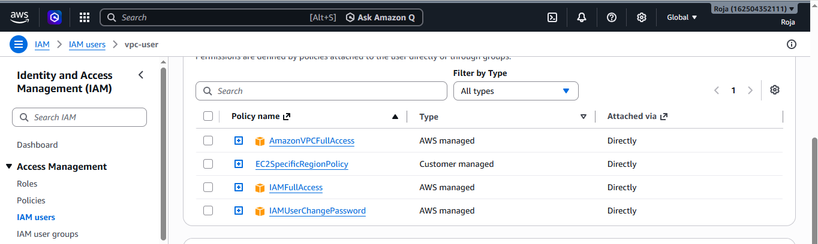

6. We have two accounts: Account A and Account B. Account A user should access an S3 bucket in Account B.

To configure cross-account access so that an IAM user in Account A can access an Amazon S3 bucket located in Account B using a bucket policy.

Step 1: Create an IAM User in Account A
- Navigate to IAM.
- Click Users.
- Click Create user.
- Enter the username: Devops
- Click Next.
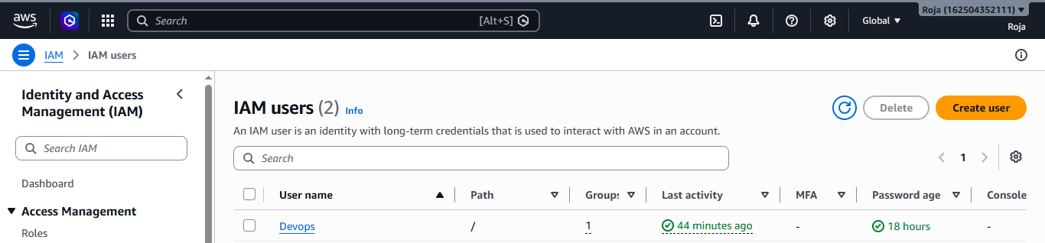
Step 2: Attach Permissions to the User
- Select Attach policies directly.
- Click Create Policy.
- Select the JSON tab.
- Paste the policy.
- Click Next.
- Enter the policy name: AccountA
- Click Create Policy.
- Attach this policy to the Devops user.
- Click Create User.
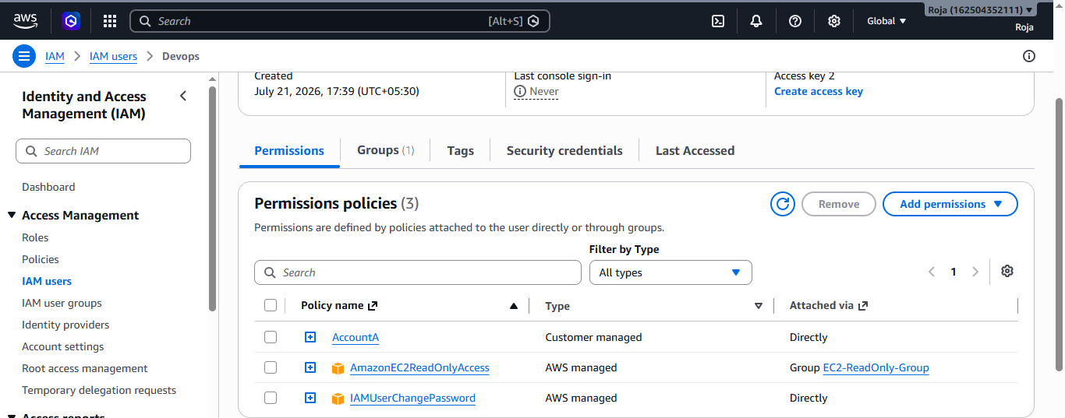

Step 3: Create Access Keys
- Open IAM → Users → Devops.
- Select Security credentials.
- Click Create access key.
- Select Command Line Interface (CLI).
- Click Create Access Key.
- Save the:
- Access Key ID
- Secret Access Key
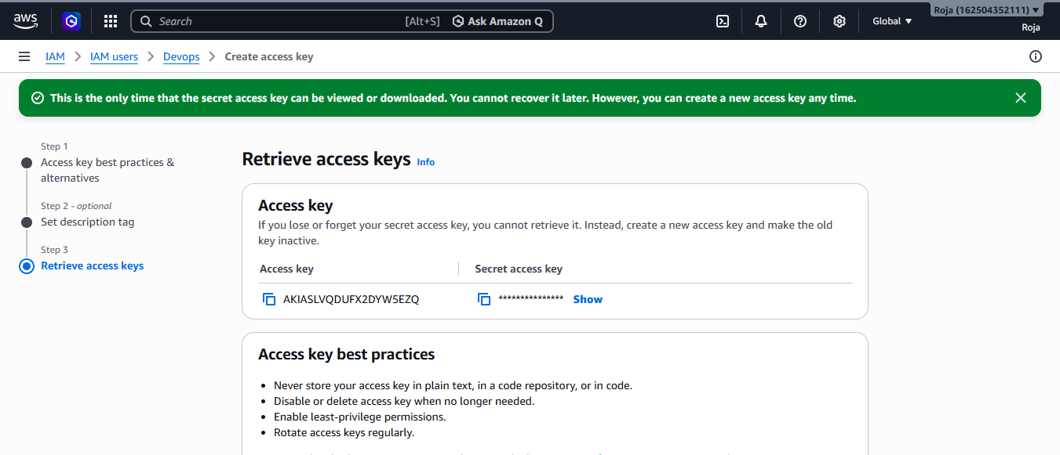
Step 4: Ask team member to Log in to Account B
- Sign in to the AWS Management Console using Account B credentials.
- Select the desired AWS Region.
- Go to S3.
- Click Create bucket.
- Enter Required Details and click on create bucket.
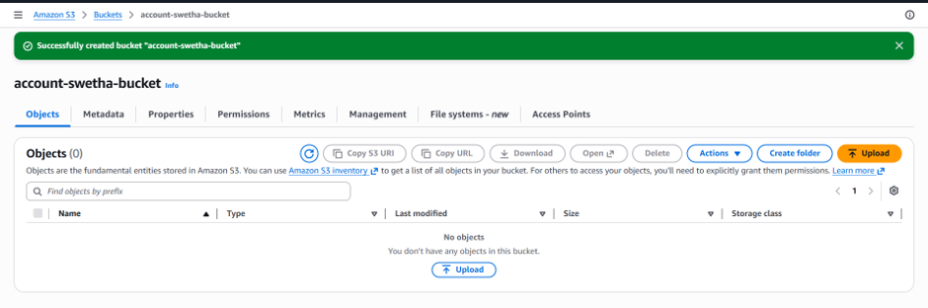

Step 5: Upload a Sample File
- Open the bucket.
- Click Upload.
- Upload a sample file such as: sample.txt
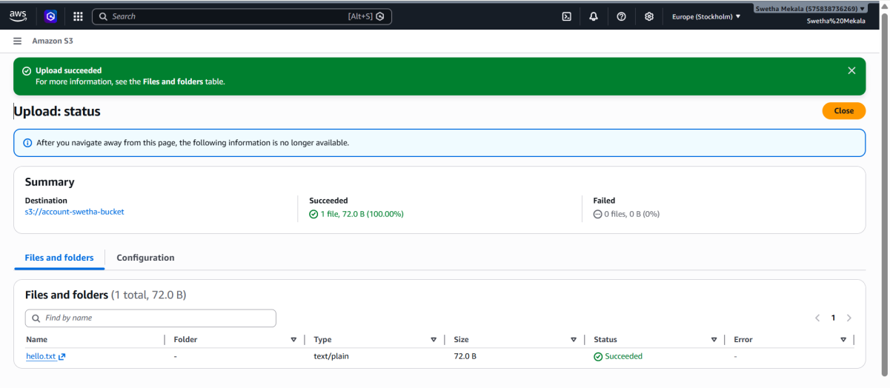

Step 6: Note the Account A Account ID
- Log in to Account A.
- Log Click your account name (top-right corner).
- Copy the 12-digit AWS Account ID.
Example:
162504352111

Step 7: Configure AWS CLI
Use the credentials of the Devops IAM user from Account A.

Step 8: Verify Cross-Account Access
- List the bucket
- List files inside the bucket
- Download a file.
